## 2018 Soccer Tournament in Shenzhen Senior High School (China)

### Introduction

Soccer competitions are popular among students in Shenzhen Senior High School (SSHS), as the World Cup in 2018 is near. Sports Association in Shenzhen (SASS) will hold a soccer tournament in Shenzhen Senior High School in order to look for young potential soccer players to participate in World Cup qualifying match. The tournament is planned to be hold in Mar 2018 and SASS has developed the tournament charter which authorized the beginning of the project and selected Xianwen Hu as the project manager. In this assignment, five topics of the project will be specified, which include project principle, project scope, and determination of the life cycle, schedule, and integration.

### Project principle

Project management can be very complex, influenced by the dynamic environment. Managing a project includes defining the scope, making schedule, monitoring and controlling, manage communication with stakeholders, and addressing other various concerns. A successful project management should comply with the following basic principles.

Project is a temporary endeavor with a definite beginning and end to create positive change or add value, such as product and service (PMI 2013). The temporary nature of a project distinguishes projects from operations, which is on-going and repetitive work. As for the proposed project, it is assumed that the charter has been developed so that means the project has already began. However, the tournament will be hold in 2018. There are about one year to prepare. If everything goes successfully as planned, the end point of the project will be 3th May 2018.

In PMBOK guide (PMI 2013), project management is categorized into five Process Group, which are Initiating, Planning, Executing, Monitoring and Controlling, and Closing. The Initiating Process Group marks the starting point, in which the project manager will be selected and the proposed project is formally authorized. The Closing Process Group is the conclusion to all project management activities in order to verify that the defined processes are completed. The end point of a project can be reached when the objectives have been realized or the objectives are determined to be unachievable. In most cases, the work will be handed over to operations (nibusinessinfo.co.uk 2017). No matter what it is, the Closing Process Group is indispensible due to the fact that it provides valuable lessons and releases the organizational resources to future projects.

The goals of projects should be specific, measurable, ambitious, realistic and time-bounded (Rangan 2017). For example, the objective of the proposed project is to hold a soccer tournament in Shenzhen Senior High School (China) in May 2018 at cost not to exceed $5, 0000. Projects, with in programs and portfolios, are usually utilized as strategies to achieve organizational objectives. Those projects that contribute the least to the portfolio’s strategic objectives may be terminated. However, project success is hard to be measured because it is a multi-dimensional construct. Different people may hold various opinions. Clear goals with measurable criteria are critical to determine how well the projects fulfill the organization’s strategic plans and gain investment. Also, with measurable and tangible objectives, project manager would better response to changing environment.

A project is usually carried out under some constraints, which have an impact on the project. Typical constraints for the soccer tournament are scope, schedule, budget, resources, and risks. If one constraint changes, other constraints are likely to be changed (PMI 2013). Due to the potential for change, progressively elaboration is required to improve the accuracy of the project management plan.

### Project scope management

With reference to PMBOK guide (PMI 2013), project scope management is a project management element to make sure that the project team executes the work required to achieve specific objectives. It also defines what is included in the project and what is excluded. Project scope management includes 6 processes, which are plan scope management, collect requirement, define scope, create work breakdown structure (WBS), validate scope, and control scope.

Plan scope management is to create a scope management plan which guides how to deal with the overall project scope management. In the case study, the scope management plan can be produced with the analysis of information including the project management plan, project charter, and the previous document for other tournaments in the school (PMI 2013). As for collecting requirements, project manager needs to identify the requirements and manage stakeholders’ expectations. Requirements need to be analyzed and documented in detail, including the conditions that need to be met by the project to satisfy formally imposed specifications and the quantified and defined expectations of stakeholders.

As for the soccer tournament, the stakeholders include students and faculties in SSHS, soccer players, the project sponsors and SASS, the possible speechers and performers, the potential volunteers, and the social media staffs. The residents near the football pitch are also the low level stakeholder, since the possible noise may negatively affect their life quality during the tournament. The requirements of the project are collected from the relevant stakeholders and are summarized in Figure 1.



Figure Requirement from Stakeholders

The next process is Define Scope which is to specify description of the project based on the requirements. The scope specifies which of the requirements is included in the project and which is excluded. The scope of the proposed project is shown in table 1, through which it specified the number of the competitions, the number of teams, and the approximate outcome of the project. This scope is just a preliminary plan of the project, which may be further specified in the later stage of the project.

The process of define scope can be iterative and require progressive elaboration as more information of the constraints are analyzed. The phase is important because the project manager will use the preliminary scope to communicate with the stakeholder telling them how the project is going and discussing what need to change. Also, as stakeholders may not remember what is specifically excluded from the scope and potential conflicts will arise from without a defined scope (Harrin 2017).

Table Scope of the tournament

|  |  |
| --- | --- |
| Project Objective | To hold a soccer tournament in Shenzhen Senior High School (China) in May 2018 at cost not to exceed $5,0000. |
|  |  |
| Deliverable | The tournament will encompass 7 competitions from 1st May to 5th May. |
|  | About 4 7vs7 soccer competitions will be hold among 8 teams in the preliminary contest 1st May 2018 |
|  | About 2 7vs7 soccer competitions will be hold among 4 winners of preliminary contest in the semi-final contest 3th May 2018 |
|  | About 1 7vs7 soccer competitions will be hold among 2 winners of preliminary contest in the final contest 5th May 2018 |
|  |  |
| Milestones | Permits approved----14th Mar 2018 |
|  | Informing students and faculties and recruiting Athletes and event staffs and volunteers----20th April 2018 |
|  | venue management(include field preparation, cleaning)----29th April 2018 |
|  | Final inspection ----30th April 2018 |
|  | Game Time ----3th May 2018 |
|  | Summary meeting, closure, reports ----4th May 2018 |
|  |  |
| Technical requirements | Negotiate with the school's official to get permit of the competition |
|  | Look for sponsor who can cover the whole cost of the competition |
|  | Rally 8 seven-people teams from students and faculties |
|  | All participates should buy insurance |
|  | To create a exciting and enjoyable gaming atmosphere, clapping stick, drinking water, uniform are provided for each audience |
|  | Drinking water, towel, uniform are provided for athletes. |
|  | 3 referees for each competition are provided in order to make sure equality. |
|  | 5 Medical staffs are available for first aid during the whole process of the competition |
|  | 20 security staffs are responsible for the venue control, including preventing audience from getting into competition places. |
|  | The championship award will include a trophy, certificate, 1000$. |
|  | Advertising the event at local education newsletters. |
|  | postpone the competition when rain |
|  |  |
| Limits and exclusions | Accommodations is not provided for both atheles and audiences |
|  | The audience won't be charged for watching TV |
|  | All the money will come from generous sponsors and be used to hold the competitions and wage of the workers. |
|  | Each team should consist of at least 7 members with a maximum of 14 members. Only 8 team will compete with each other.All full-time students and faculties are eligible to take part in this competition. There is no biases.The recurition will be closed if the maximum participants are met. |
|  | Working staffs will be provided with working lunch. Dinner is not provided. |
|  | The name of each team should be |

The following phase is to decompose the total scope of the proposed project into WBS, which provides a graphic vision of what kind of work need to be done. With analyses of project scope statement and requirement documentation which are described before, the WBS of the proposed project is shown in figure 2. The proposed project is divided into four major parts, which are planning, recruiting, marketing, and gaming (tournament). Each of the four major parts is then subdivided into smaller work pages.

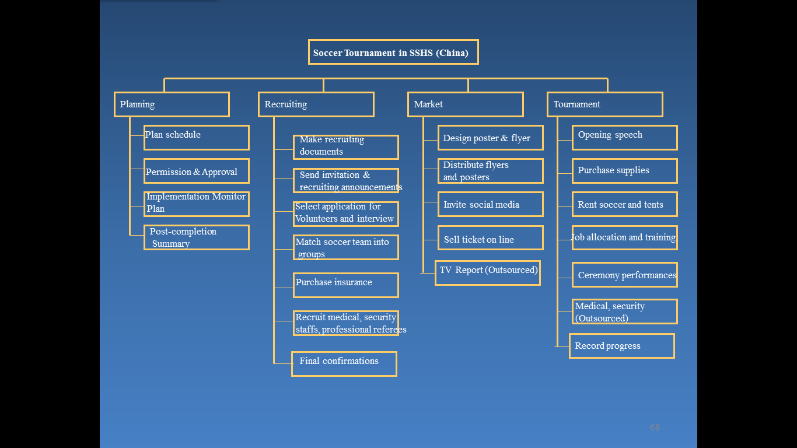

Figure WBS for the tournament

With the preliminary scope and WBS done, the project manager should validate the scope by obtaining the acceptance of the deliverables from sponsors and other customers. In this case study, Xianwen Hu, the project manager, should obtain the approval from the both the sponsor of Sports Association in Shenzhen (SASS) and the official of Shenzhen Senior High School.

Finally, the scope should be controlled and monitored during the whole process of the project. The subsequent changes should be checked by the Perform Integrated Change Control Process in case of scope creep. In order to identify the need for change, regular review meetings are integral, in which those who are involved in the project development can summarize the progress of the completion of work.

### Project life cycle

According to the PMBOK guide (PMI 2013), the generic life cycle structure includes four major phases: starting the project, organizing and preparing, carrying out the project, and closing the project. The phase within life cycle should not be confused with Process Group which are initiating process group, planning process group, executing process group, monitoring and controlling process group, and closing process group, for the activities of Process Groups may be done and recur within each phase of a project lifecycle. When there is more than one phase, the phase-to-phase relationships can be sequential, overlapping and parallel depend on the level of control required and the size and complexity of the project.

At the moment, the proposed project was just officially declared of its existence with the development of Charter. However, future changes may be incurred when changes is met. From the figure 3 which is from PMBOK guide (PMI 2013), the development of project charter marks the project entering into the organizing and preparing phase. However, the project management plan has not finished yet. The scope, schedule, and integration management will be specified in this assignment. The implementation and closure has not started yet.

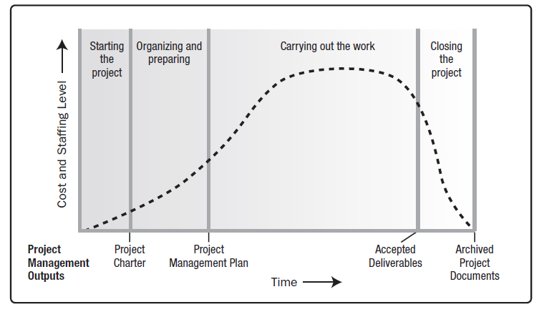

Figure Typical Cost and Staffing level Across a Generic Project Life Cycle Structure (PMI 2013)

In addition, there are three types of project life cycles, which are predictive life cycles, iterative and incremental life cycles, and adaptive lifecycles (PMI 2013). The predictive lifecycles are usually used when the products is well understood. The scope, time and cost are determined in detail as early as possible. The phases in the project can be either sequential or overlapping. The detailed planning for work can be done in the near future. After that work is finished, more detailed planning need to be done for the work in next phase (Rowley 2017). However, in iterative and incremental life cycles and adaptive life cycles, the detailed scope and plan is only determined for the current iteration and phase at a time.

Iterative and incremental life cycles are often used in large and complex projects in order to reduce risk by incorporating lessons learned from iterations (PMI 2013). Project phases repeat one or more project activities until the product meet the exit criteria for the phase. The adaptive life cycles are iterative and incremental. The phases or iterations of adaptive life cycles are more rapid than that in the iterative and incremental life cycles. Some processes within the iterations can be concurrent when there is a rapid change. At the end of each iteration, the product will be reviewed by customer. The feedback from the customer is used to adjust the scope of the next iteration. In this way, the sponsor and customer representatives are continuously engaged to provide feedback to ensure that the final product meet the real needs (PMI 2013).

The scope of the case study can be very detailed because the soccer tournaments were usually held in several schools near SSHS. Those who are responsible for developing the scope of this specific tournament can refer to the similar activities in the past. However, innovation is needed so that the tournament can excel. Therefore, predictive lifecycles can be applied to the case study.

### Project Schedule Management

Project schedule management is to ensure all the defined work is finished on time. A project schedule refers to what needs to be done, which resource should be utilized, and when the work is due.

The first step, define activities, is to decompose work packages into activities, which is good for the subsequent project management work. Then, the project manager should identify the logical sequence of work in order to create a realistic project schedule with great efficiency. The Third phase is to estimate the type and amount of resource required to perform each activity which allows for a more specific estimation of cost and time. The resource types include material, human resources, equipment, and supplies. Based on the above estimation, the project schedule can be developed. The rough schedule of the proposed project including specific activities, duration, and timetable, is shown in figure 4. Further refinement to the schedule requires repeatedly revision of the time estimates and resource estimates. In order to track the project progress, a more accurate schedule is required.

It should be noted that although the charter of the project is developed about 1 year before the tournament, the duration estimated in the preliminary schedule is from the day of planning schedule to the day when the tournament is over considering that the time needed to make preparation for the tournament is much less than one year. The surplus time would be reserved for risk management and further adjustment. The schedule in figure 4 describes that the duration of the whole project is about 40 days if everything goes successfully as planned in the project management plan. However, as the more accurate estimation of the availability of other sources become available, the schedule needs further corrections.



Figure Preliminary Schedule for the tournament

The final phase is Control schedule which is to monitoring the deviation between the plan and the actual progress and take corrective actions to minimize risk. It should be noted that the subsequent change request to the baseline should be approved by the Perform Integrated Change Control Process.

### Project Integration management

Project integration management is one of the project management elements that balance competing constraints, select choices about resource allocation and manage interdependencies all aspects of the project management, covers all five phases of a project (PMI 2013).

First, develop project charter usually is initiated by a higher authority than a project manager and requires a joint effort between the performing and requesting organizations (Guru99.com. 2017), In the case study, the tournament charter is developed by the president of Sports Association in Shenzhen (SASS) after a careful discussion with the school official. Within the charter, the project name, description and deliverables of the project are specified as above. Xianwen Hu is selected as the project manager. Then, a comprehensive project management plan is produced by integrating all subsidiary plans. The soccer teachers in school and activity advisor are good sources for consultation in order to develop the management plan. Next, the project is executed following the project management plan. During the process, the project manager is responsible for not only executing the performance of the defined activities, but also managing any possible unplanned activities. In addition, the project manager should collect the work performance data about the completion quality of deliverable, which is used as inputs to the Monitoring and Controlling Process Group (PMI 2013). Likewise, potential changes may be required in order to meet the defined requirements (Guru99.com. 2017).

The monitor and control project work is integral part to integration management. Several mid-term review meeting will be carried out. The representations of stakeholders will be invited to attend the meeting and the project manager should report the status of the completion of each work in order to keep tournament project transparent. Once an accident occurs or some change requests are initialed, the project manager and other stakeholders should be informed as soon as possible to determine. if control methods are needed or not. Control methods include carrying out correct actions and plans to solve any potential issue.

Next, Perform Integrated Change Control is to ensure that all change requests must be checked across the whole project following the process stipulated in the Change Control and Configuration Control Systems. Every change request will be either adopted or rejected by a responsible authority (PMI 2013). The main difference between the monitor and control project work and integrated change control is that the second one allows for changes within the project with consideration to the overall project scope and reduces the risk, while the former one emphasis on the defined scope is well executed (Guru99.com. 2017).

The Close Project is the formal completion of all project activities, in which the project manager will review the scope to make sure the completion and archived relevant documents. This phase is valuable because it is the formal ending of the project work which not only releases the organizational resource to new endeavors but also provides useful experiences for future projects.

### References

Project Management Institute (PMI), 2013, *A guide to the project management body of knowledge (PMBOK guide), (2013). 5th ed*. Beijing China: Publishing House of Electronics Industry.

Rangan, K. (2017). *Basic Principles Of Project Management*. Simplilearn.com, viewed 25 Mar. 2017, < https://www.simplilearn.com/project-management-basic-principles-article>.

Watt, A. (2017). *3. The Project Life Cycle (Phases) | Project Management*. Opentextbc.ca. viewed 25 Mar. 2017, < https://opentextbc.ca/projectmanagement/chapter/chapter-3-the-project-life-cycle-phases-project-management>

Rowley, J. (2017). *5th Edition PMBOK® Guide—Chapter 2: Project Life Cycle Types (Predictive, Iterative, Agile)*. 4squareviews. viewed 25 Mar. 2017, <https://4squareviews.com/2013/02/01/5th-edition-pmbok-guide-chapter-2-project-life-cycle-types-predictive-iterative-agile>.

Guru99.com. (2017). *Project Integration Management Tutorial: Definition, Process & Plan*. viewed 26 Mar. 2017,< http://www.guru99.com/project-integration-management.html >.

Harrin, E. (2017). *What Is Project Scope Management?*. The Balance. viewed 26 Mar. 2017,< https://www.thebalance.com/what-is-project-scope-management-3875060 [Accessed 26 Mar. 2017>.

.

nibusinessinfo.co.uk. (2017). *Basic principles of project management*. viewed 26 Mar. 2017,<https://www.nibusinessinfo.co.uk/content/basic-principles-project-management>.